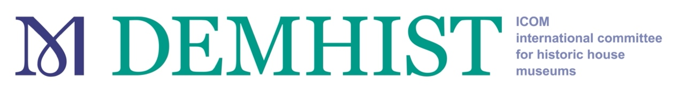

Historic House Museums for a Sustainable World: Challenges and Opportunities

THEME

Partners and Sponsors: ICOM-Netherlands, Cultural Heritage Agency of the Netherlands (RCE), Dutch Culture, Mondriaan Fund.

For more information, please go to the conference website:
www.icom-demhist2021.com/

Museums are increasingly aware of the need to become more sustainable. To this end, many museums are already doing some green work and green thinking, thus contributing to the United Nations’ Sustainable Development Goals (SDGs) and to creating a sustainable future. Government and funding bodies are increasingly demanding environmental assessment. As agents of social responsibility we are expected more and more to deal with the results of environmental change such as flooding and drought, and to fulfil our role as a forum for public debate. We believe that despite the Covid-19 Pandemic and its devastating effect on personal, public, political, economic and cultural life over this past year it is important to also keep looking beyond it. Sustainability remains even more relevant for the future of society and museums alike. As museums and museum professionals, we all have an important role to play in building a more peaceful, equal, and sustainable future.

In the Workplan for the Paris Climate Change Agreement, 2018 museums are recognised as key sites for climate change education. That means that as museums, we are considered to have great potential to create awareness among visitors, other sectors and our immediate environment. In practice however, the activities that museums develop to become more sustainable are mainly in the field of waste and electricity consumption. The activities to raise awareness are relatively rare. Many museums do not have structural policy regarding sustainability, nor do they monitor their progress. In other words: environmental sustainability is not yet mainstream or systemic within the museum sector. A lack of resources and expertise are obvious obstacles that stand in the way.
The ambitions and challenges are great: less energy, less waste, less water consumption, smarter use of resources and raw materials, more quality in the management and use of the collection, and more and better public participation. It affects every part of our work; it is about our building, collection management, operations, and the relationship with our public. How can we as historic house museums translate these ambitions into practice? How can we deal with the challenges, starting with our historic buildings, which are often far from sustainable to begin with? How can we protect our valuable historic houses from climate change? However, at the same time we must ask ourselves: how can we make use of our great potential as vectors for social and sustainable change? And can responses to the Covid-19 pandemic be a guide in the right direction? Since our plans and habits have been disrupted, we have had to find new and ways of working, we have had to explore new tools and revisit traditional ones to reach our audiences and continue engaging with their diverse communities. How can we make this efforts and capacities sustainable to support community resilience and an effective recovery during and after the Covid-19 crisis?
These and other questions will be posed at our DEMHIST 2021 Online Conference, organized in conjunction with the Cultural Heritage Agency of the Netherlands (RCE). During the conference, we will hear experts on sustainability address these issues; we will examine the challenges; we will visit inspiring examples; and we will see that a lot is possible.

